Lim, Francis Raemark L. 11/27/2019

2ECE-C

**Problem 1:**

Code:

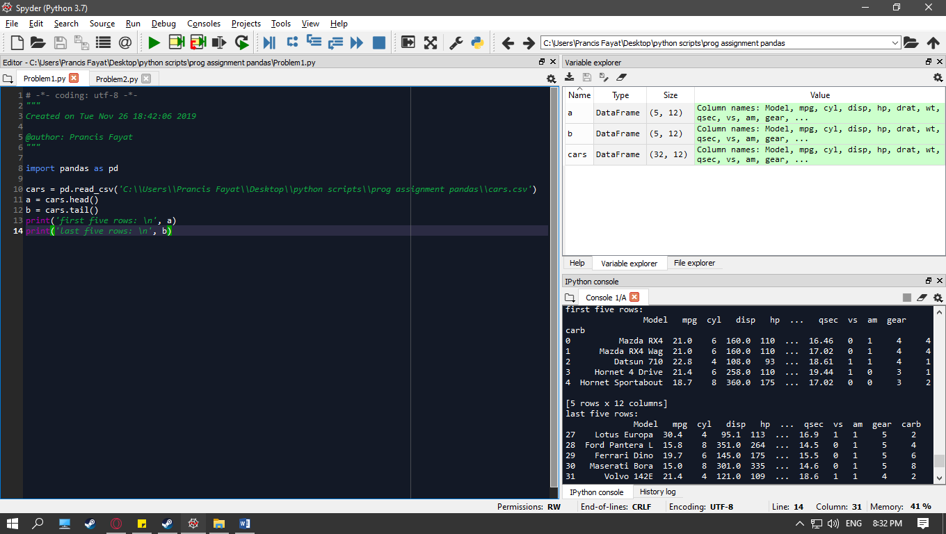

a) cars.csv

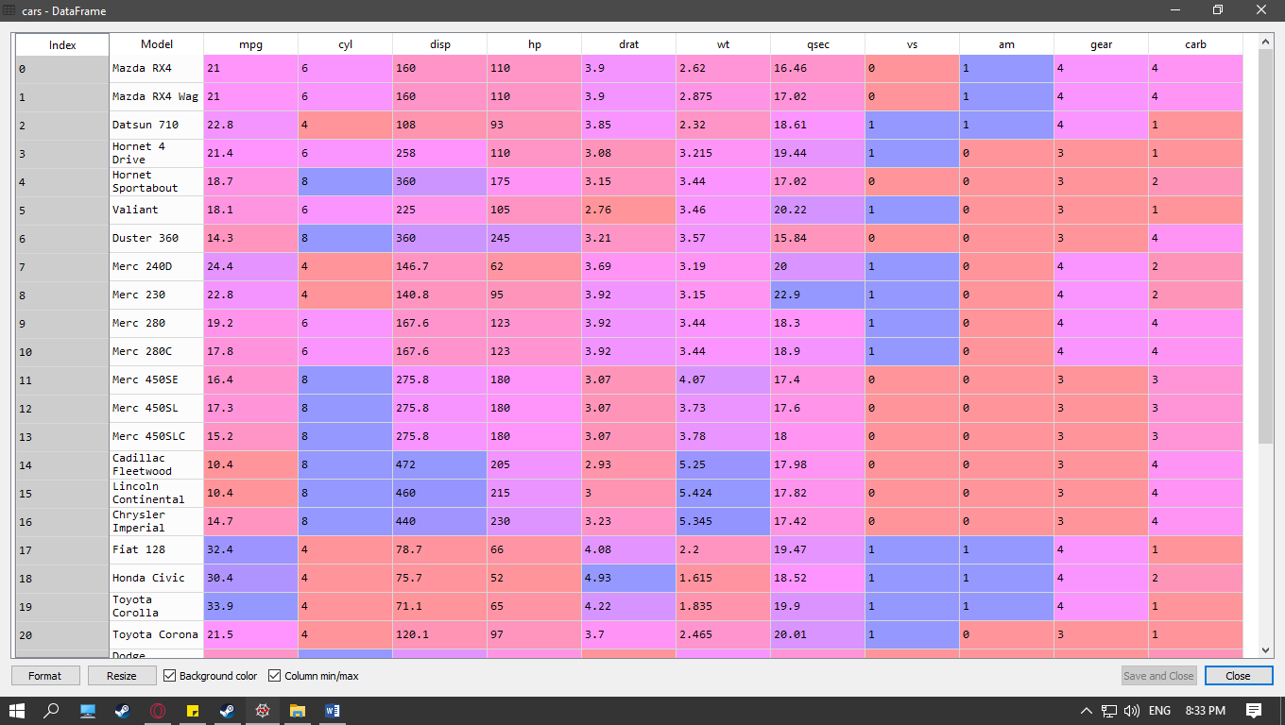

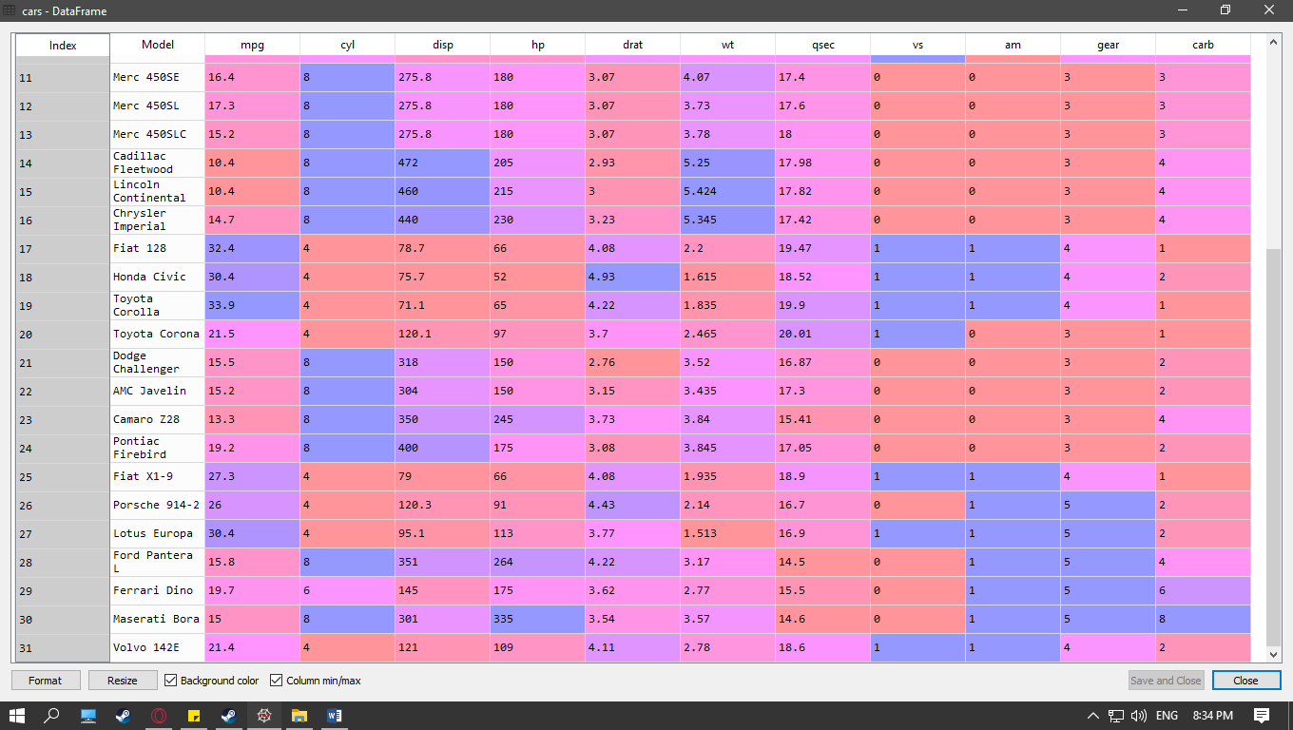

b) first five and last five rows:

a = cars.head()

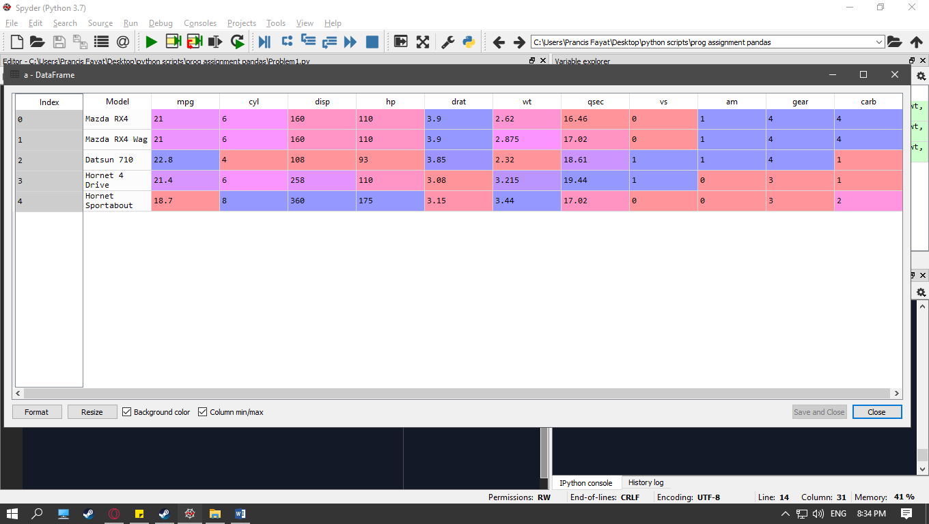

b = cars.tail()

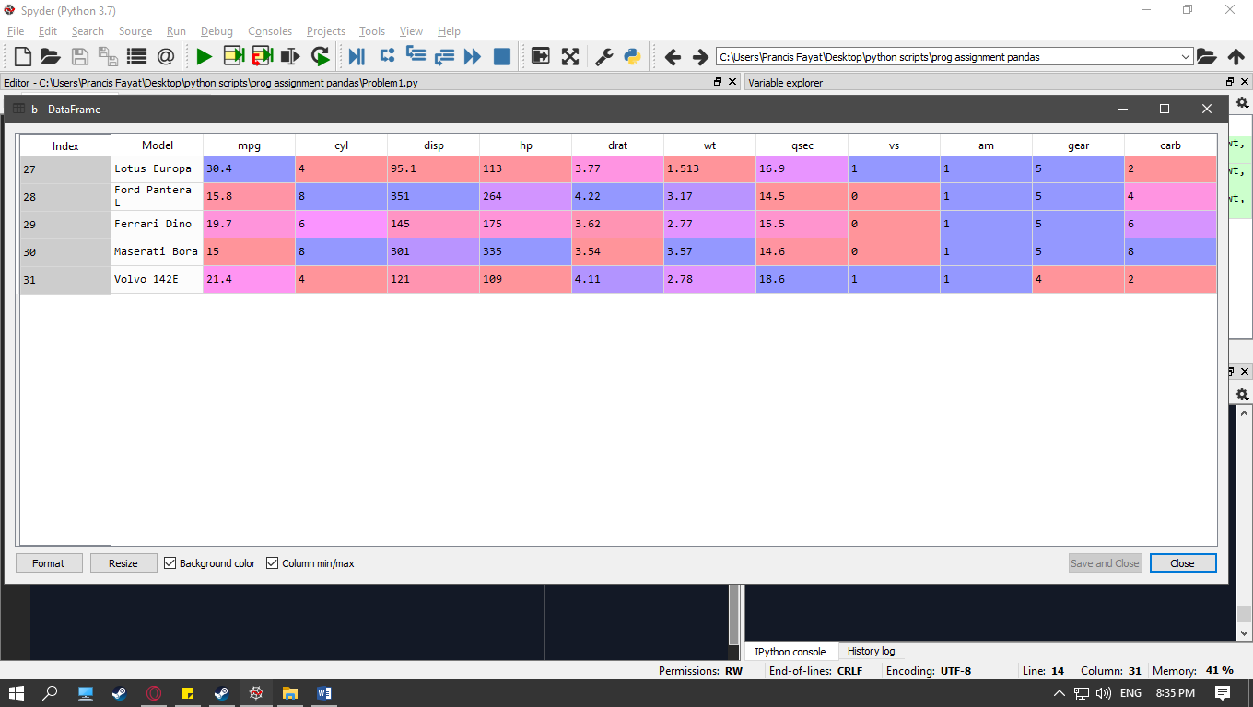

**Problem 2:**

Code:

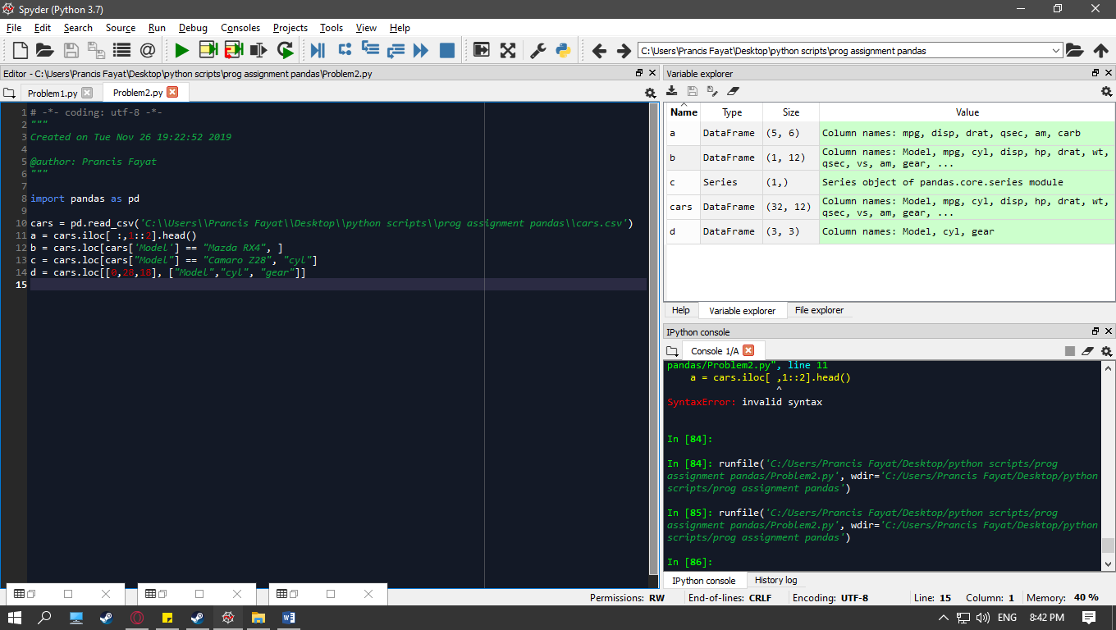

a) first five rows with odd-numbered columns of cars

a = cars.iloc[ :,1::2].head()

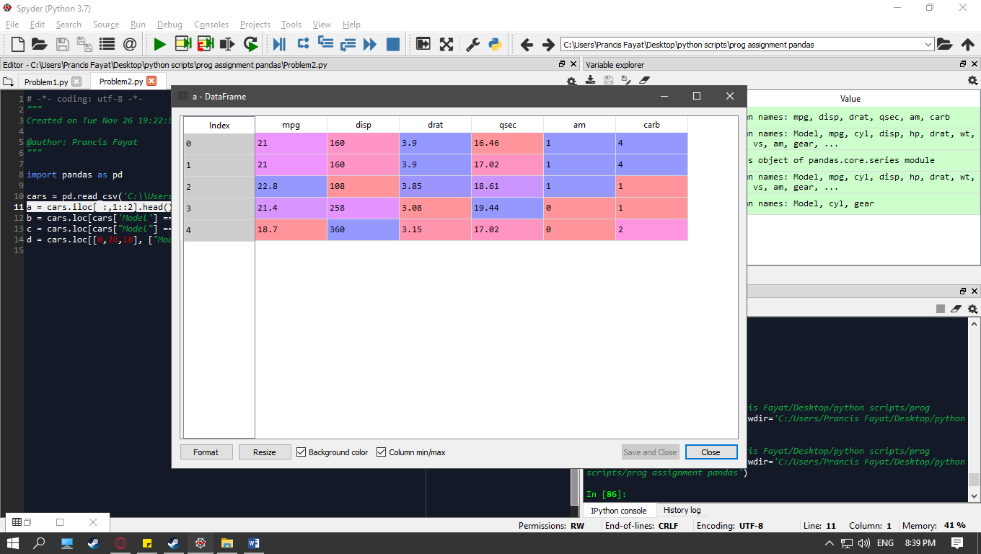

b) Row that contains the ‘Model’ of ‘Mazda RX4’

b = cars.loc[cars['Model'] == "Mazda RX4", ]

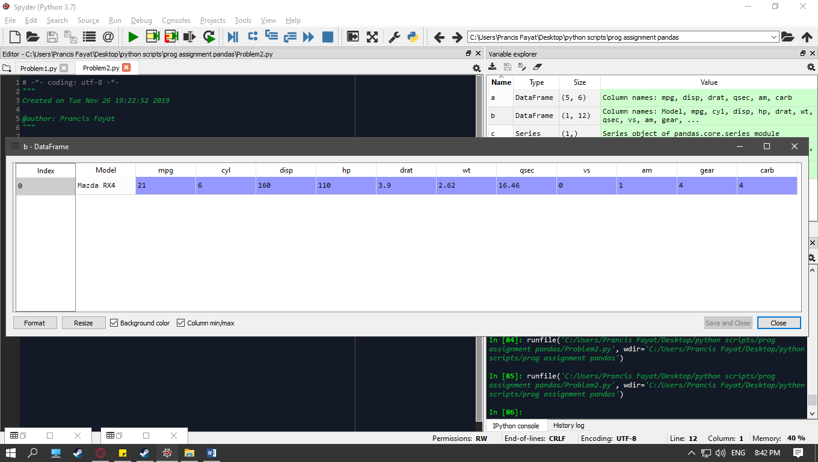

c) How many cylinders(‘cyl’) does the car model ‘Camaro Z28’ have?

c = cars.loc[cars["Model"] == "Camaro Z28", "cyl"]

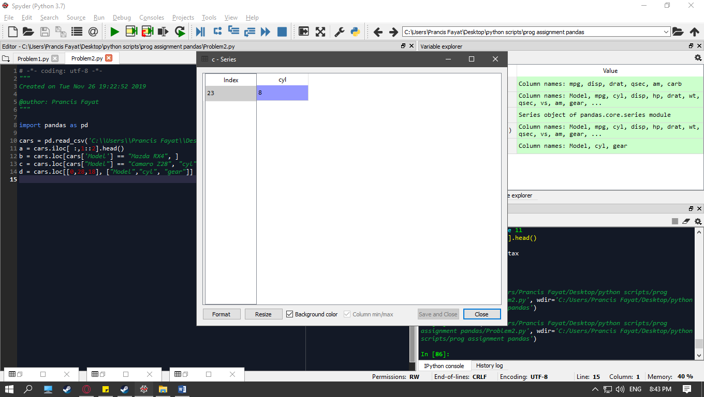

d) determine how many cylinders (‘cyl’) and what gear type (‘gear’) do the car models ‘Mazda RX4 Wag’, ‘Ford Pantera L’, and ‘Honda Civic’ have.

d = cars.loc[[0,28,18], ["Model","cyl", "gear"]]

